EXPERIMENT : 21
Implementation of Towers of Hanoi Using Prolog.
AIM:
To write and execute a Prolog program to solve the Towers of Hanoi problem by moving disks from the source rod to the destination rod using an auxiliary rod.
PROCEDURE:
- Open SWISH Prolog SOFTWARE
- Enter the Prolog program in the editor.
- Define the base condition for moving one disk.
- Define the recursive rules for moving multiple disks.
- Click the Run button to load the program.
- Enter the query hanoi(3, a, c, b). in the Query box.
- Click Run to execute the program.
- Observe the sequence of disk movements.
PROGRAM:
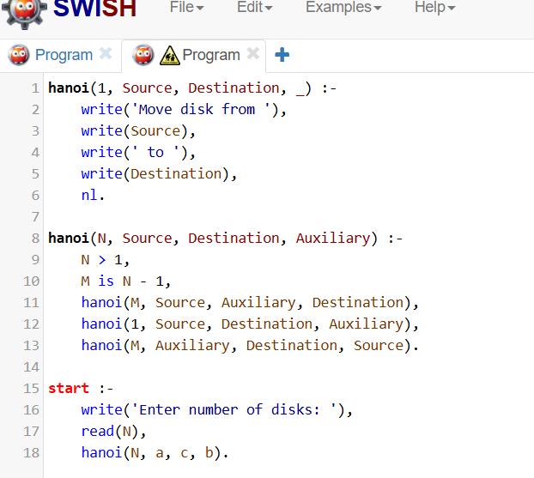

OUTPUT:
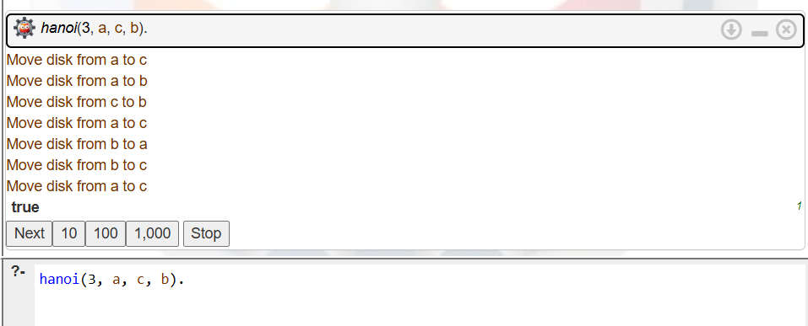

RESULT:
Thus, the Prolog program to implement the Towers of Hanoi problem using recursion was successfully executed.

